

**PAMANTASAN NG LUNGSOD NG MAYNILA**

College of Information Systems and Technology Management (CISTM)

**ICC 0104-1 – Data Structures and Algorithms**

*A.Y. 2023- 2024*

**Group 4**: Searching

**Submitted by**:

Abundo, Jonalene Ryza B.

Dela Peña, Daniella Mae N.

Diamzon, Momer Ailes M.

Lau, Trisha Mae R.

Mahusay, Lindsay G.

Matanga, Sophia Vien V.

Rivera, Ramyll C.

Sibayan, Joan F.

BSCS 1-1

1. **Main Menu**

Source Code in C++

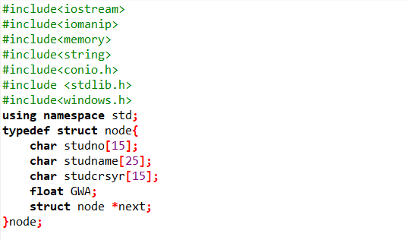

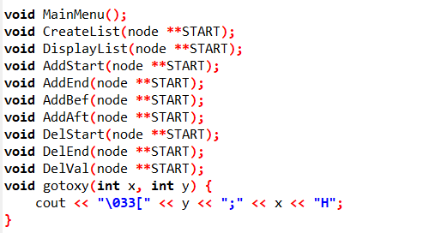

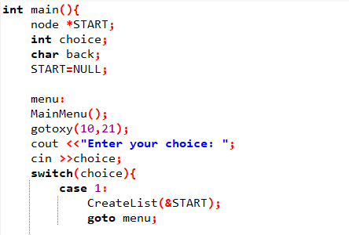

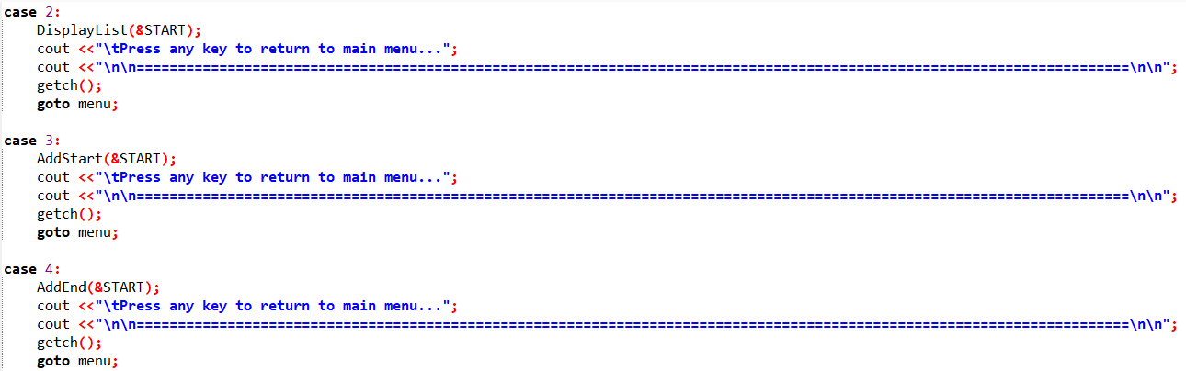

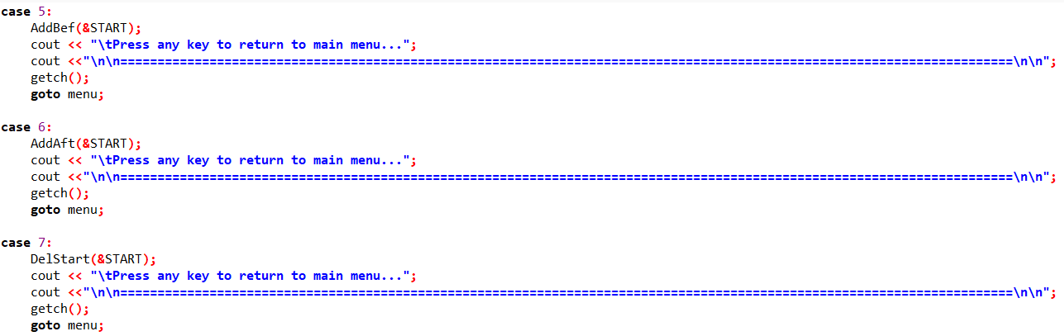

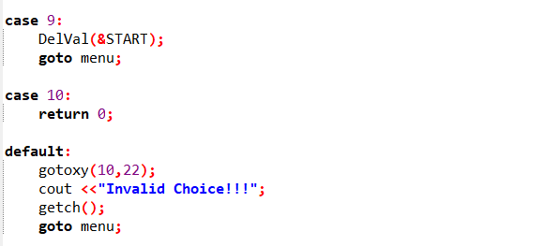

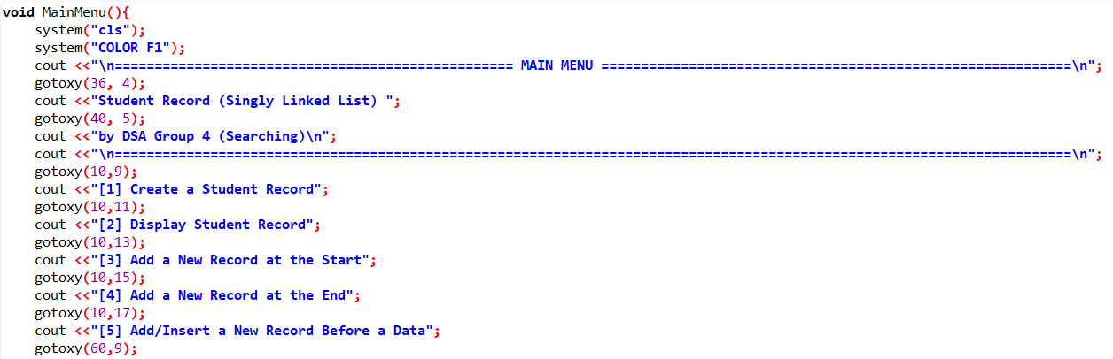

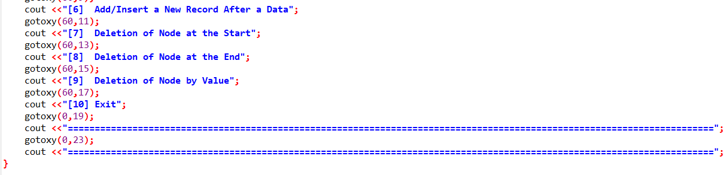

Output

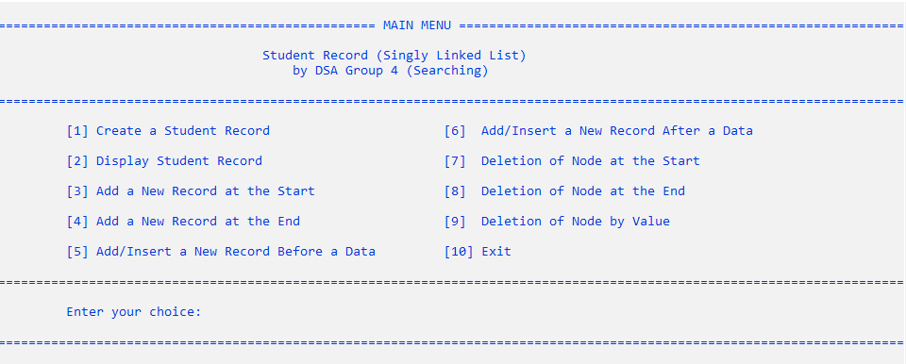

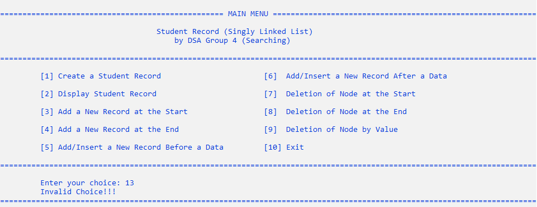

*(Figure 1: Main Menu – Functions)*

1. Creation of Single/Singly Linked List

Source Code in C++

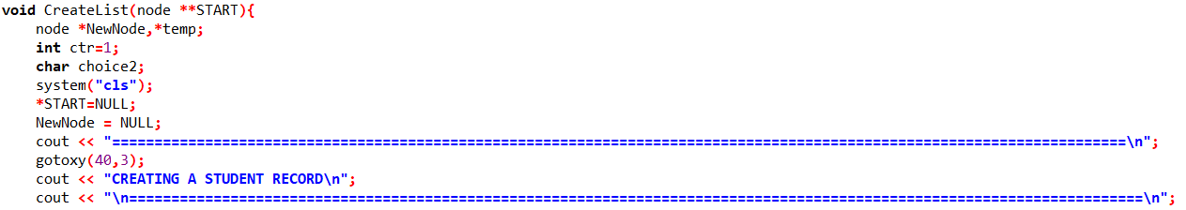

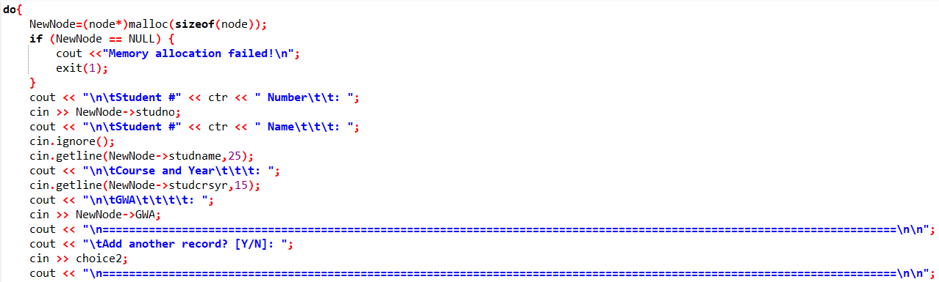

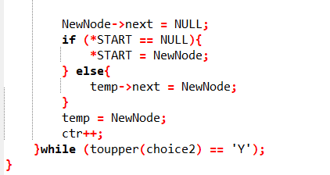

Output

* In the main menu, entering 1 prompts you to go to another screen which allows you to create a student record.

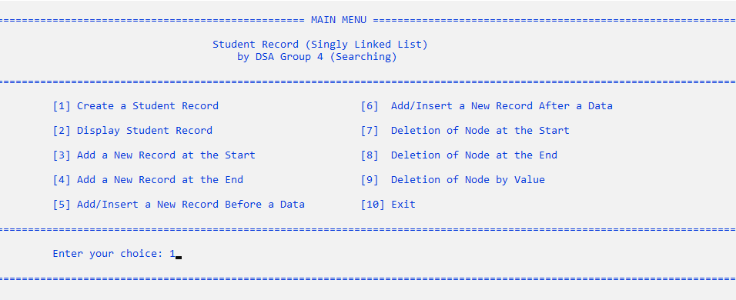



*(Figure 1: Main Menu – Functions)*

* Once you are in the “Creating A Student Record” screen portion, it will allow you to input the student number, name, course and year, and GWA. After inputting the data, it will ask you whether you will add another record or not.

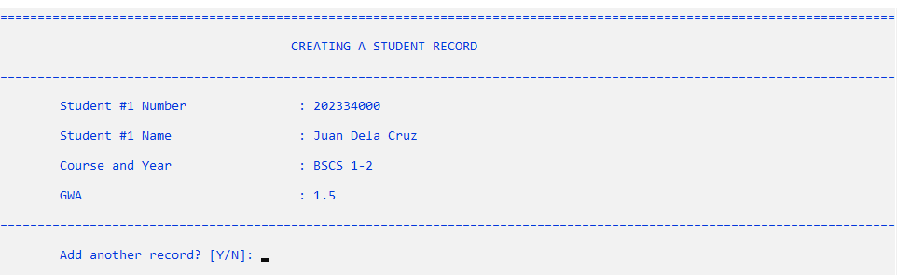

*(Figure 2.2: Inputting Data in the “Creating a Student Record” Portion)*

* If you select y/Y, it will allow you to input another student record.

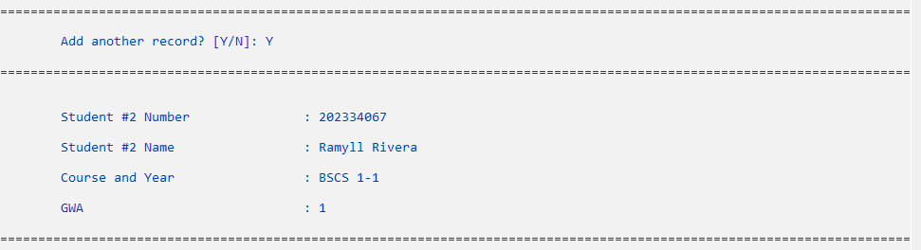

*(Figure 2.3: Selecting “Y” will allow you to input another student record)*

* If you select n/N, it will prompt the user to go back to the main menu

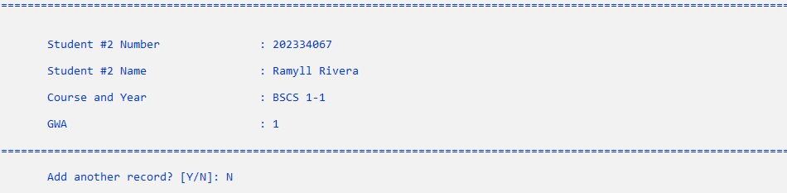

*(Figure 2.4: Selecting “N” will return to the main menu)*

1. Traversal of Single/Singly Linked List

Source Code

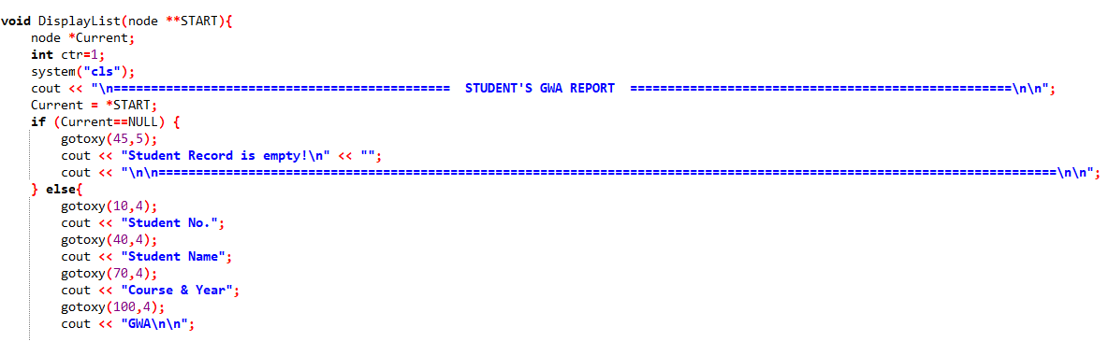

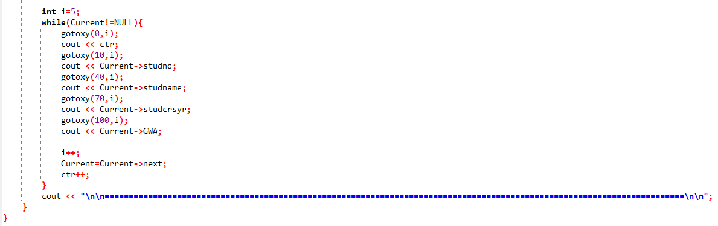

Output

* In the main menu, entering 2 prompts you to go to another screen which allows you to display the student record.

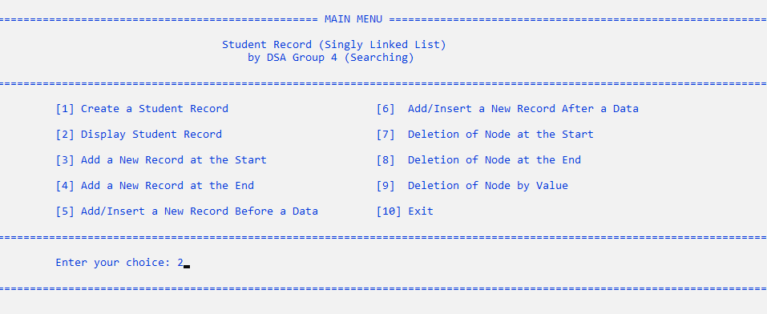

*(Figure 3.1: Main Menu – Selecting “Display Student Record” Option)*

* After that, the program will display the Student’s GWA Report which contains all the data you entered in the creation of the student record.

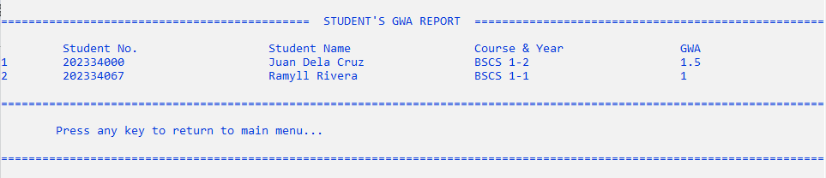*(Figure 3.2: Displaying the Student’s GWA Report in Tabulated Format)*

1. Adding a New Node at the Start

Source Code in C++

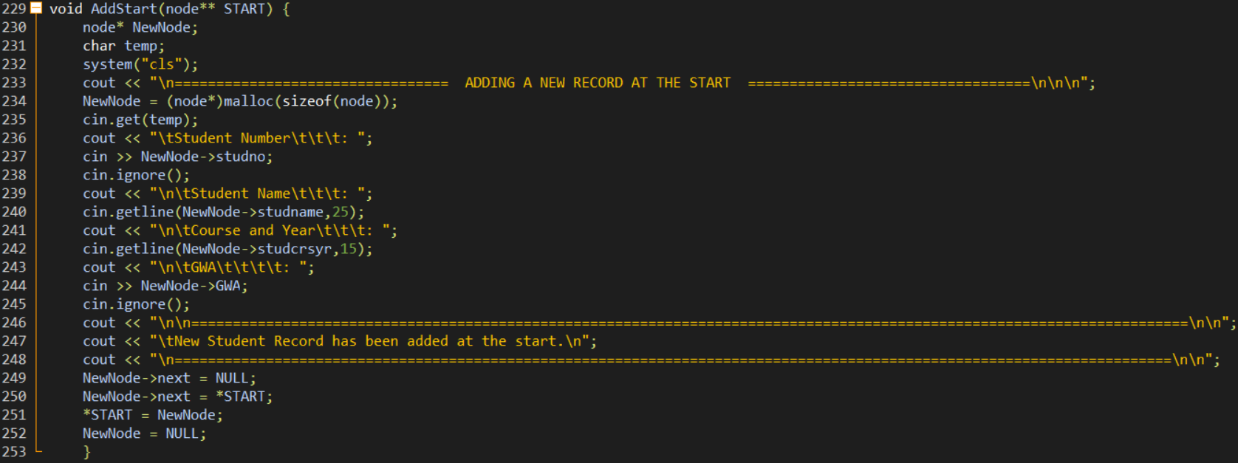

Output

* In the main menu, entering 3 prompts you to go to another screen which allows you to add a new record at the start.

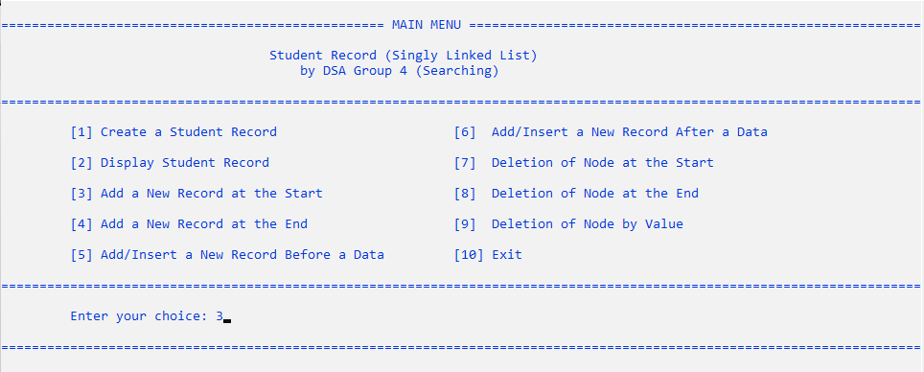

*(Figure 4.1: Main Menu – Selecting “Add a New Record at the Start” Option)*

* Once you are in the “Adding a New Record at the Start” screen portion, it will allow you to input the student number, name, course and year, and GWA.

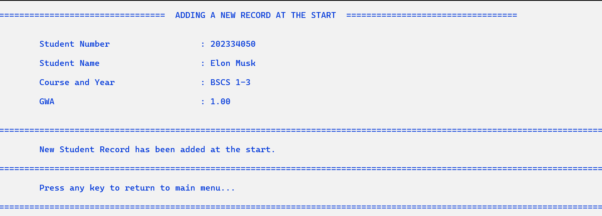*(Figure 4.2: Entering Data You Wish to Add at the Start of the Node)*

* After entering the given data, it will display a message that it has successfully added to the student record. This record will display at the beginning of the list.

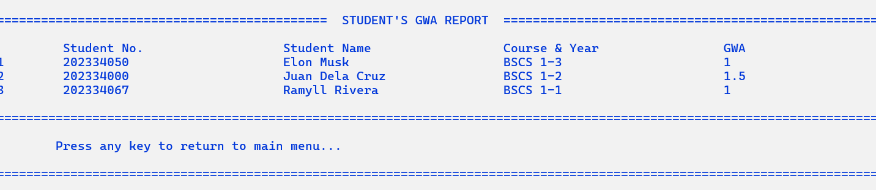

*(Figure 4.3: Displaying the New Student Record Added at the Start of the Node)*

1. Adding a New Node at the End

Source Code in C++

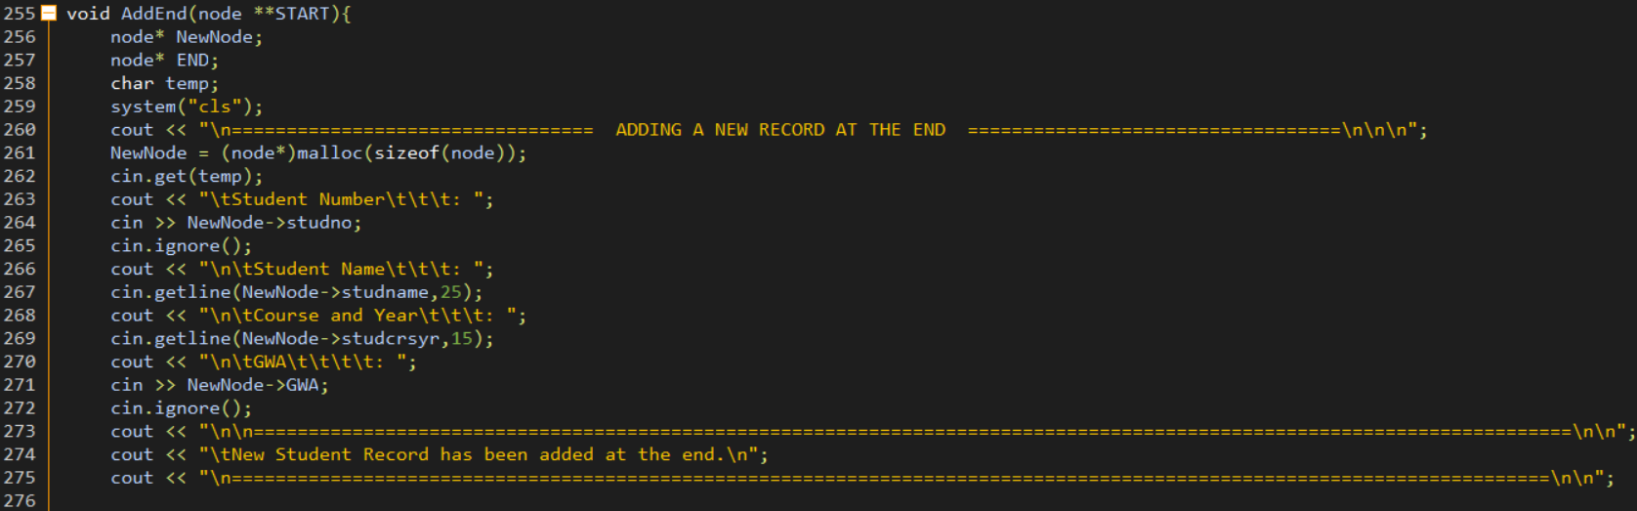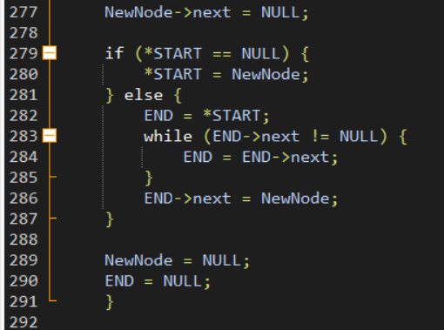

Output

* In the main menu, entering 4 prompts you to go to another screen which allows you to add a new record at the end.

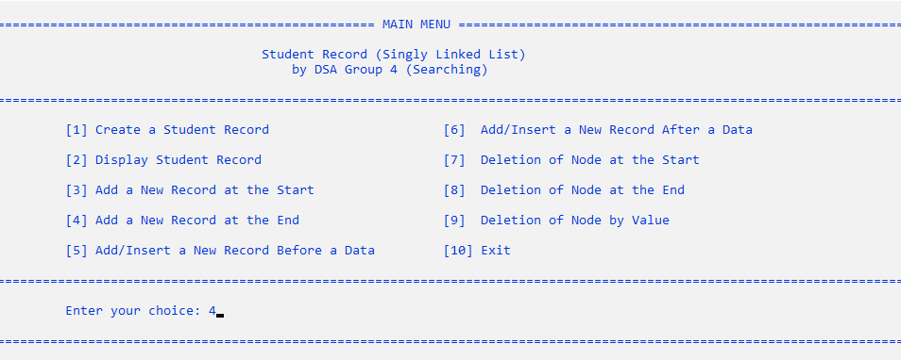

*(Figure 5.1: Main Menu – Selecting “Add a New Record at the End” Option)*

* Once you are in the “Adding a New Record at the End” screen portion, it will allow you to input the student number, name, course and year, and GWA.

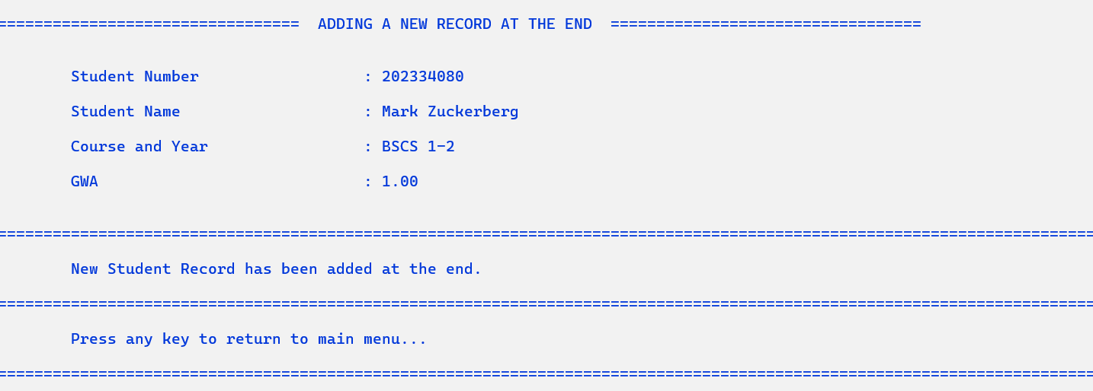

*(Figure 5.2: Entering Data You Wish to Add at the End of the Node)*

* After entering the given data, it will display a message that it has successfully added to the student record. This record will display at the end of the list.



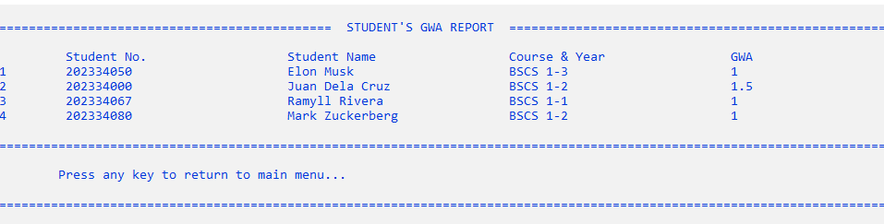

*(Figure 5.3: Displaying the New Student Record Added at the End of the Node)*

1. Adding/Insertion of New Node Before a Node (data)

Source Code in C++

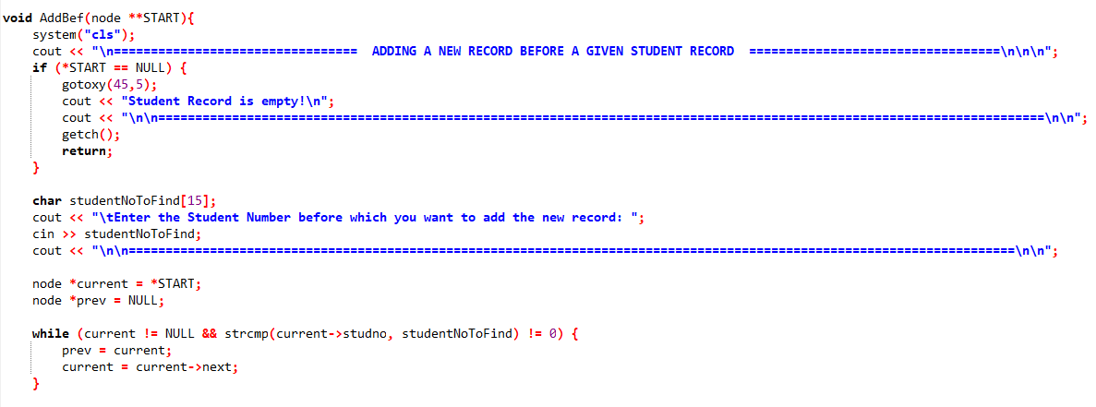

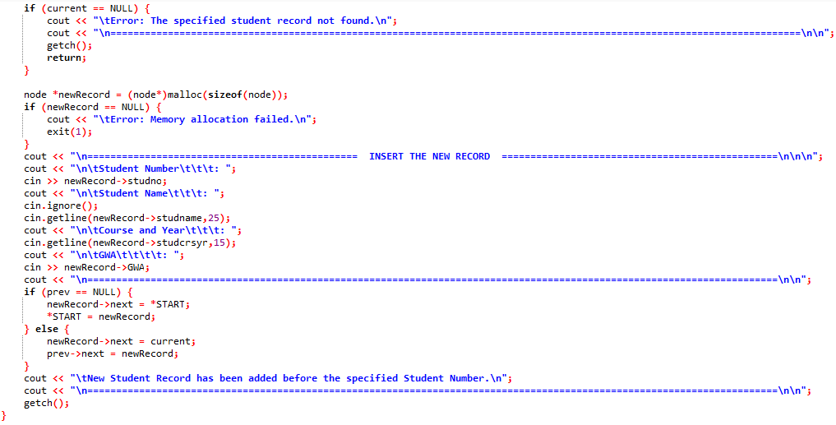

Output

* In the main menu, entering 5 prompts you to go to another screen which allows you to add/insert a new record before a specified node.

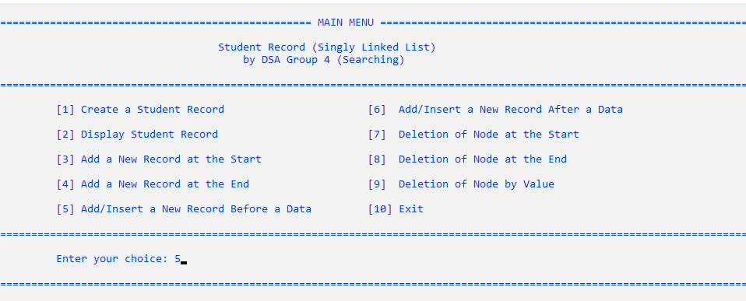

*(Figure 6.1: Main Menu – Selecting “Add/Insert a New Record Before a Data” Option)*

* After selecting the option, it will now proceed to another screen which prompts user to find the student number before you wish to add the new record.
* IF the student number is found: it will prompt the user to insert the new record before the specified student number. After entering the given data, it will display a message that it has successfully added to the student record. Finally, it will now prompt the user to return to the main menu.

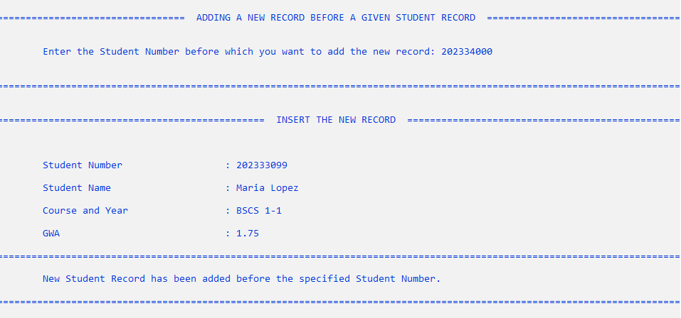

*(Figure 6.2: Inserting a New Record Before the Specified Node Operation)*

* Return to main menu and it will display the newly added student record before the specified node.

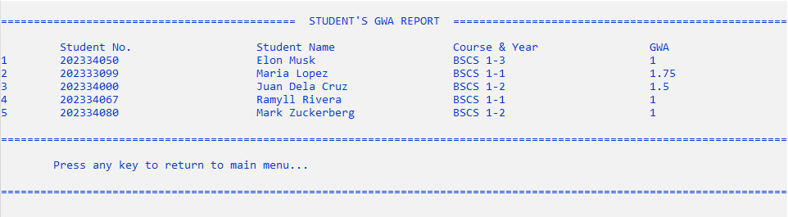

*(Figure 6.3: Displaying the New Student Record Added Before the Specified Node)*

* IF the student number is NOT found: it will display an error message that it has not been found within the record. It will now prompt the user to return to the main menu.

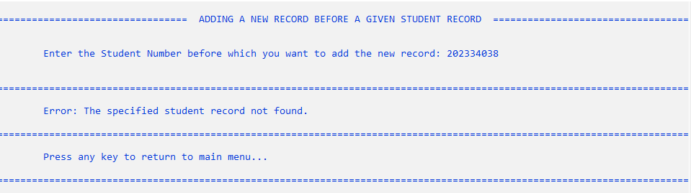

*(Figure 6.4: Not Found Student Number)*

1. Adding/Insertion of New Node After a Node (data)

Source Code in C++

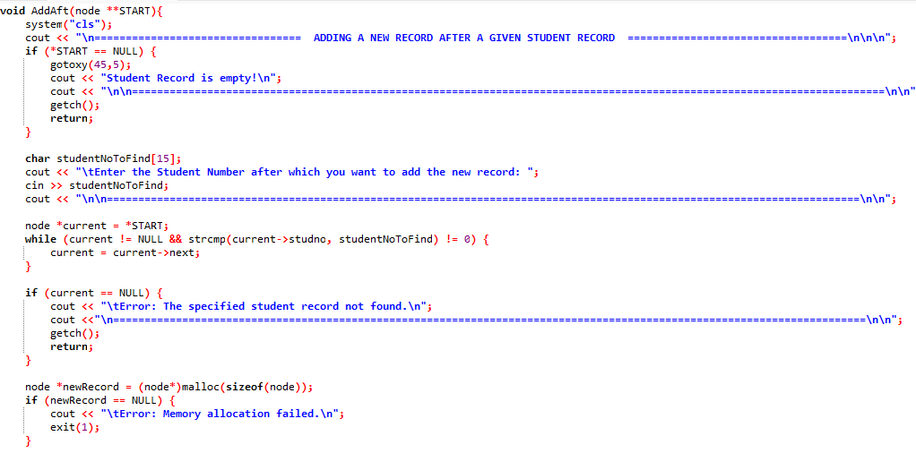

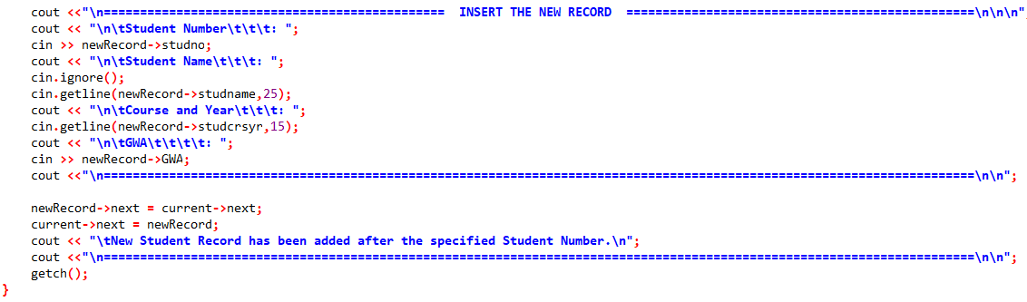

Output

* In the main menu, entering 6 prompts you to go to another screen which allows you to add/insert a new record after a specified node.

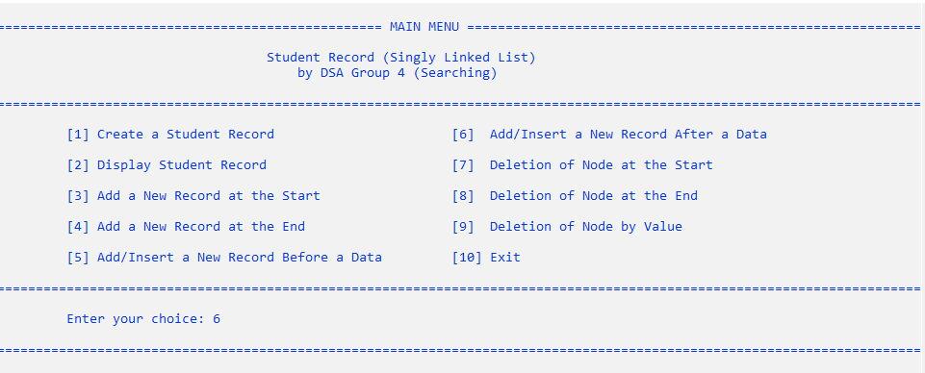

*(Figure 6.1: Main Menu – Selecting “Add/Insert a New Record After a Data” Option)*

* After selecting the option, it will now proceed to another screen which prompts user to find the student number after you wish to add the new record.
* IF the student number is found: it will prompt the user to insert the new record after the specified student number. After entering the given data, it will display a message that it has successfully added to the student record. Finally, it will now prompt the user to return to the main menu.

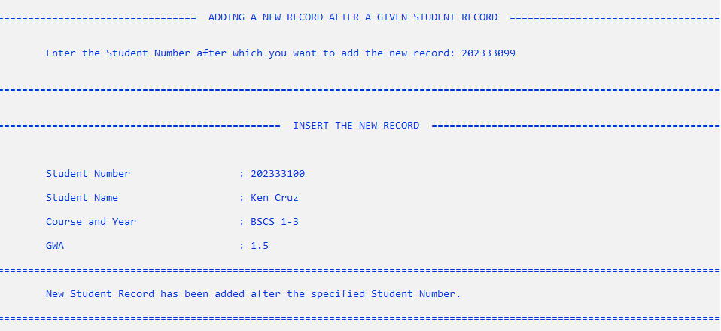

*(Figure 7.2: Inserting a New Record After the Specified Node Operation)*

* Return to main menu and it will display the newly added student record after the specified node.

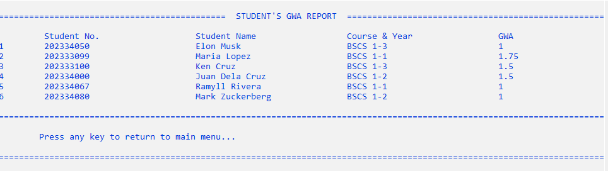

*(Figure 7.3: Displaying the New Student Record Added After the Specified Node)*

* IF the student number is NOT found: it will display an error message that it has not been found within the record. It will now prompt the user to return to the main menu.

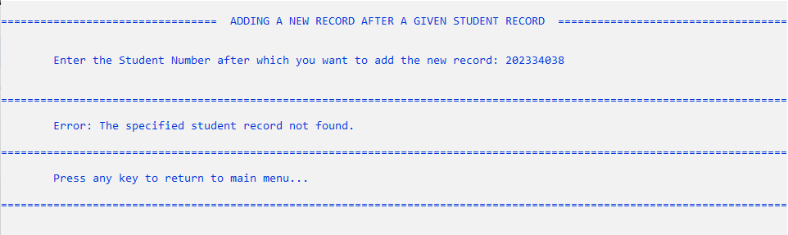

*(Figure 7.4: Not Found Student Number)*

1. Deletion of Node at the Start

Source Code in C++

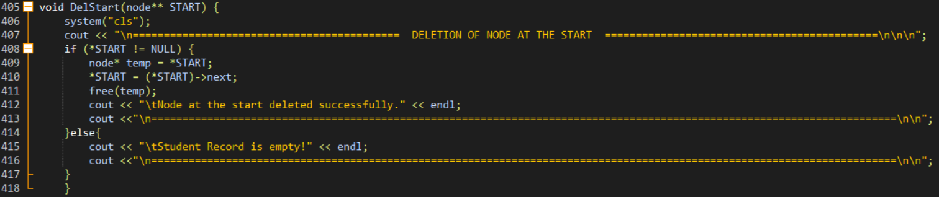

Output

* In the main menu, entering 7 prompts you to go to another screen which allows you to delete a node at the start.

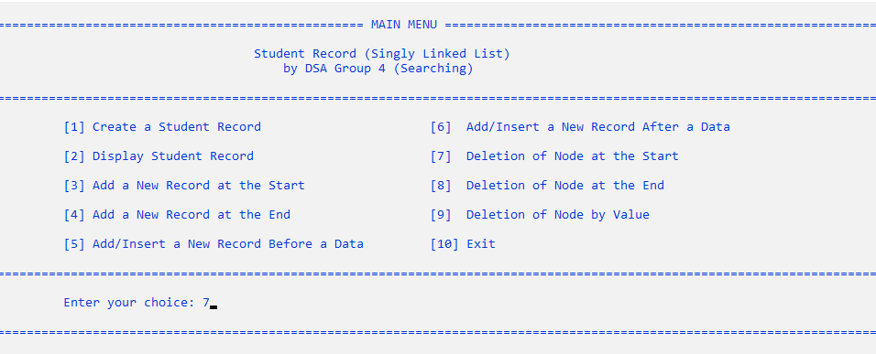

*(Figure 8.1: Main Menu – Selecting “Deletion of Node at the Start” Option)*

* After selecting the option, it will now proceed to another screen which automatically deletes the record at the start of the list. Then, it will display a message that it has successfully deleted the student record.

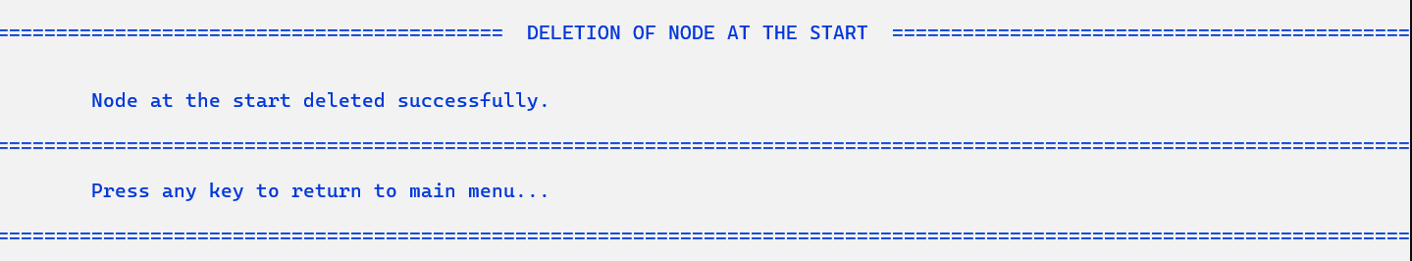



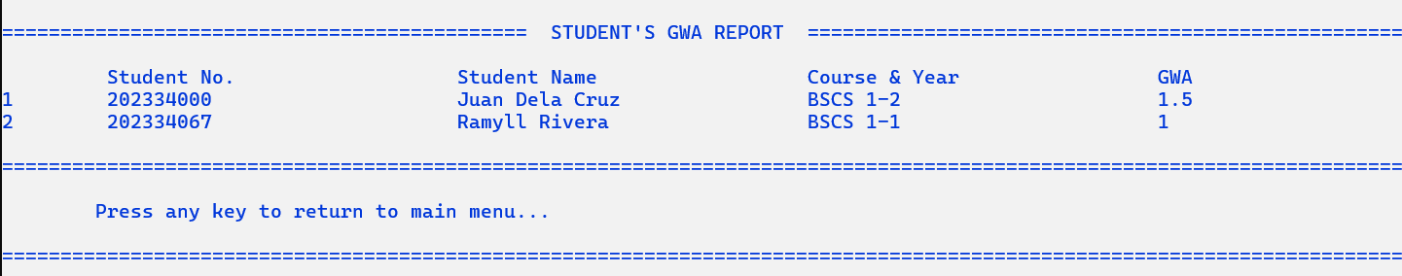

*(Figure 8.2: Displaying the New Student Record Added After Deleting the Node at the Start)*

* If the student record is empty, it will not delete the node at the start. It will also display a message that says “List is empty. No node to delete.” It will also prompt the user to return to the main menu.

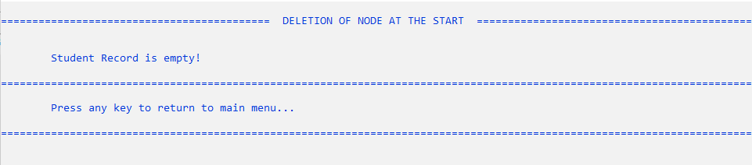

*(Figure 8.3: List Empty)*

1. Deletion of Node at the End

Source Code in C++

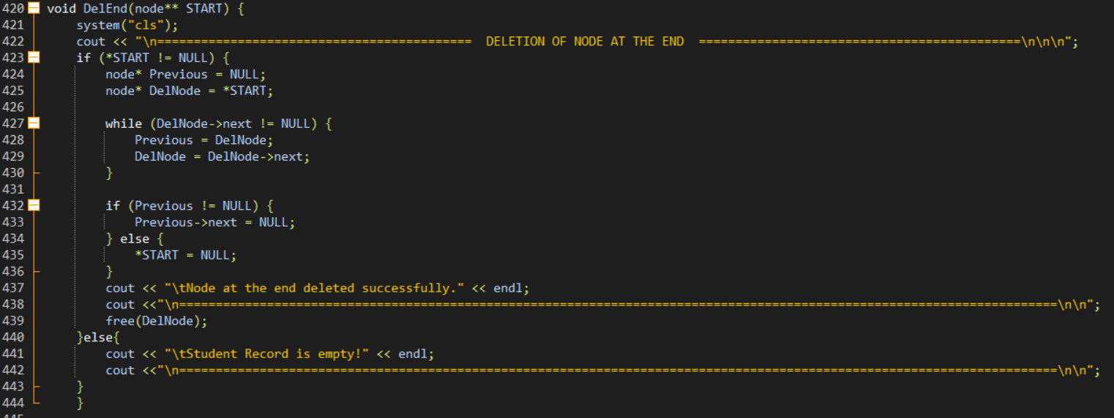

Output

* In the main menu, entering 8 prompts you to go to another screen which allows you to delete a node at the end.

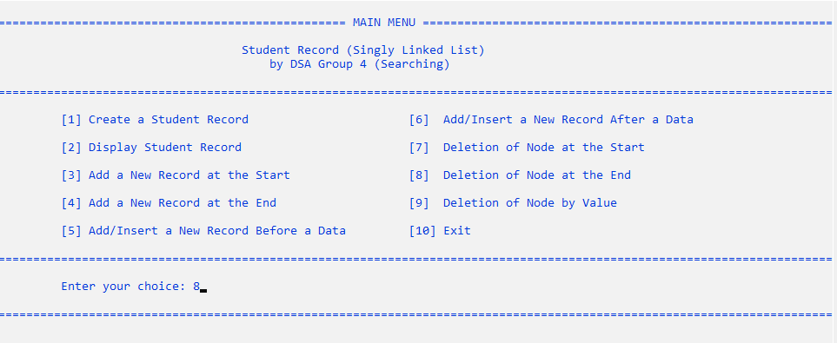

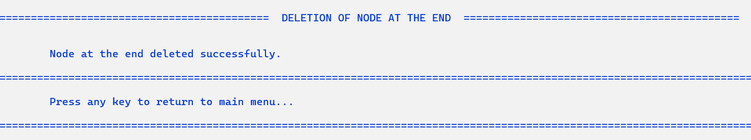

*(Figure 9.1: Main Menu – Selecting “Deletion of Node at the End” Option)*

* After selecting the option, it will now proceed to another screen which automatically deletes the record at the end of the list. Then, it will display a message that it has successfully deleted the student record.

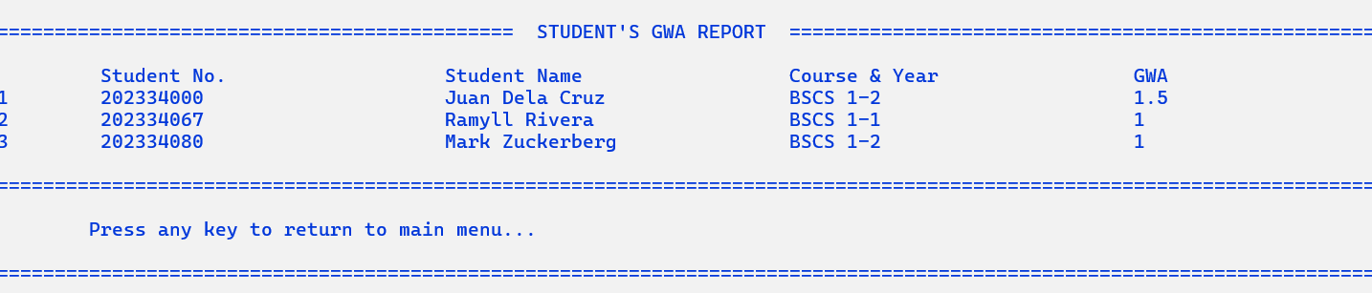

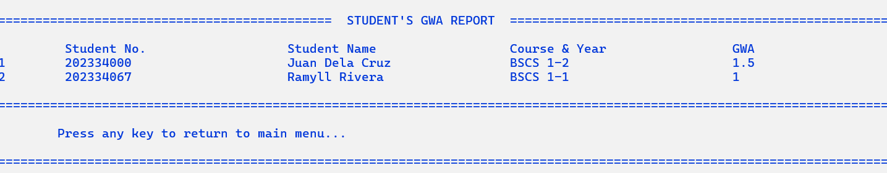

*(Figure 9.2: Displaying the New Student Record Added After Deleting the Node at the End)*

* If the student record is empty, it will not delete the node at the end. It will also display a message that says “List is empty. No node to delete.” It will also prompt the user to return to the main menu.

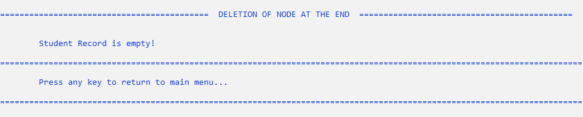

*(Figure 9.3: List Empty)*

1. Deletion of Node by Value (Data)

Source Code in C++

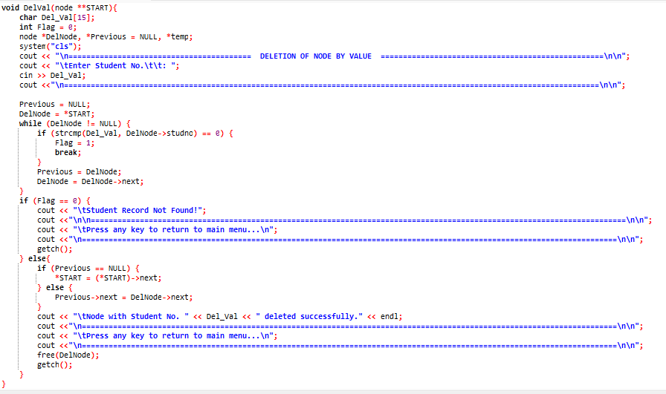

Output

* In the main menu, entering 9 prompts you to go to another screen which allows you to delete a node by value.

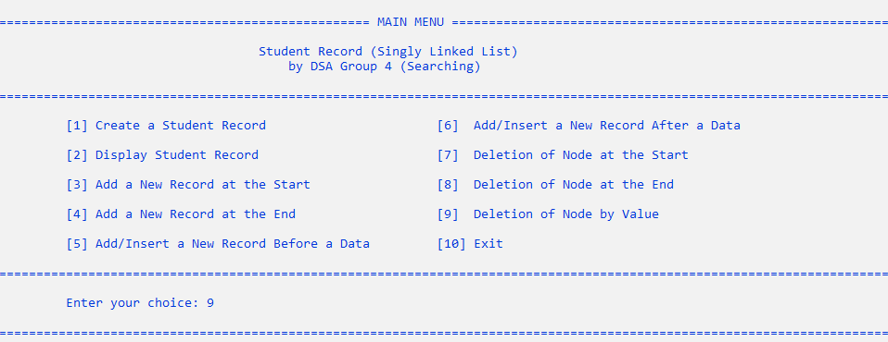

*(Figure 10.1: Main Menu – Selecting “Deletion of Node by Value” Option)*

* After selecting the option, it will now proceed to another screen which prompts user to find the student number after you wish to delete.

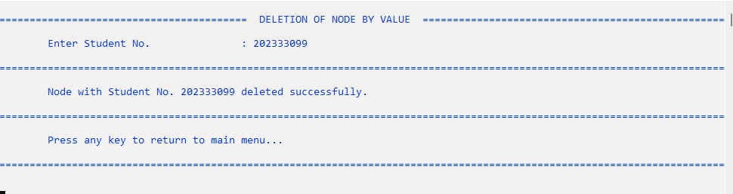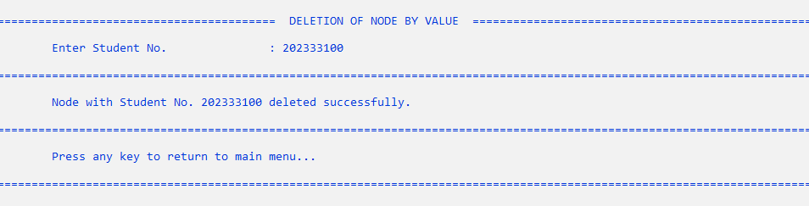

*(Figure 10.2: Deletion of Node by Value Operation)*

* Return to main menu and it will display that the specified student record has been successfully deleted.

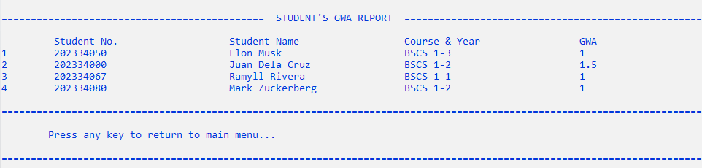

*(Figure 10.3: Displaying the New Student Record Added After Deleting the Specified Node)*

* If it does not find the specified value, it will not delete the specified node. It will also display a message that says “Student Record Not Found!” It will also prompt the user to return to the main menu.

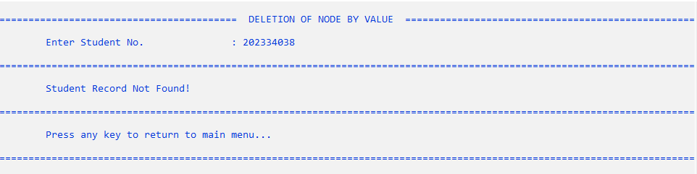

*(Figure 10.4: Student Number Not Found)*